Design brief for the Energy Saving Suitcase

We are looking for someone to design and make 5 Energy Saving Suitcases which will be used as community engagement tools by volunteers across East Sussex to talk to people about energy in the home.

Deadline for submissions | 12.5.23
Budget | Up to £3,500 for all 5 suitcases.  This needs to include all of the costs – materials, labour, printing, design work, stock images etc.
Submission requirements | To submit your proposal for the work please send the following:  - A written description of your idea  - A sketch of how it would look  - A rough budget  Please email kate@energisesussexcoast.co.uk  To discuss your idea please call Kate on 07840 485344
Who we are | Energise Sussex Coast is a Community Benefit Society. Our mission is to act co-operatively to tackle the climate crisis and energy injustice through community owned renewable power and energy saving schemes.  Through our award winning energy advice service we give free impartial advice to all residents to make homes warmer and reduce energy costs and debts.  Through different projects we aim to engage communities by empowering and inspiring people to reduce the energy wasted in their homes. We also champion new and innovative community led schemes to generate and own local renewable energy.  For more information visit: www.energisesussexcoast.co.uk
What is the Energy Champion project? | Our project will:  • Facilitate community-led action on fuel poverty and climate change  • Train and mentor residents and community groups to tackle the current energy crisis and develop long term resilience.  We will train and support volunteer Community Energy Champions, supported by an Energy Advisor, to help their local residents manage soaring energy bills.
What is an Energy Champion? | An Energy Champion is a volunteer who gives energy advice to local people to help them bring down their energy bills and save energy.  Energy Champions might also set up Community Energy projects such as thermal imaging for local homes, solar streets, hosting energy workshops and more.  Who is the role suitable for?  Energy Champions are friendly, helpful and knowledgeable local people. Energy Champions are good with people and happy to attend local events and chat to local people about their energy use. No specific background is needed as full training is provided.  The Energy Champion role is very rewarding as it’s a chance to genuinely help people in a very tangible way. Energy Champions do something about climate change by bringing down carbon emissions and help address the cost of living by helping people bring their energy costs down.
The product:
What is the product? | 5 x Energy Saving Suitcases  What is an energy saving suitcase?  This is an easily portable community engagement resource which volunteer Energy Champions take to events to highlight how to draught proof and what appliances use a lot of energy.  It might be a suitcase or something of equivalent size and portability.  The “suitcase” opens up and contains interactive, playful, colourful and engaging information and items highlighting 2 important areas of energy efficiency:  - Draught proofing  - Information on how to draught proof. Please use the information from this guide: https://www.cse.org.uk/advice/diy-draft-proofing/  - Information on draught proofing materials with examples that people can see and touch. Please include physical examples of draught proofing tape, door brushes, chimney balloons, letter box draught excluders.  - Information on the monetary saving of draught excluding referencing information from the Energy Saving Trust: https://energysavingtrust.org.uk/advice/draught-proofing/  - Understanding your energy costs  - Information on how much appliances cost to run average for typical usage (e.g. 1 hour for a washing machine, 10 minutes for a microwave etc). Please include: washing machine, tumble dryer, fan heater, electric immersion heater, TV, oven, shower, kettle. Please use the information here and a link to this tool: https://www.citizensadvice.org.uk/consumer/energy/energy-supply/get-help-paying-your-bills/check-how-much-your-electrical-appliances-cost-to-use/  - Information on how to bring down the cost of appliances:  - When buying new appliances buy the most energy efficient one you can by looking at the energy rating: https://energysavingtrust.org.uk/advice/home-appliances/  - Use a SMART meter or energy monitor to see how much you use.  - Energy guzzlers to energy saver switches – please use information on the attached ‘energy guzzlers’ powerpoint.
Aim(s):  - What is the purpose of the product? | - An engagement tool for volunteers to take out with them to help with conversations around the easy and low cost things we can do to save energy and bring down energy costs.  - An educational tool to raise awareness and increase knowledge about draught proofing and the costs of every day appliances.
Target audience: | - Attendees at community fairs, in community centres in East Sussex  - All ranges of knowledge – ranging from no interest or knowledge to lots  - Adults (although it could have a fun element for children to if that works)
Distribution/promotion | The suitcases will be given to volunteers when they train up as Energy Champions to assist with their community engagement work. Champions will also have a range of information leaflets to give out.
Design specifications
Format | An easy to carry or roll suitcase (or equivalent) which will fit in the average boot of a car and can be transported easily by one person alone on public transport.  The suitcase should open up into a display or be very easy to assemble for the volunteer.  The suitcase needs to be durable and sturdy. It will be used by the volunteer for at least the 3 year project.
Images | We have some images of volunteers and community events and some stock images available but we do not have images of all the measures we are highlighting in the brief so you might need to buy stock images. Please let us know what images you are looking for and we can advise.
Specific design requirements | Visually colourful, playful, interactive  The following need to be visible in the suitcase:  Energise Sussex Coast logo  Energy Champions logo  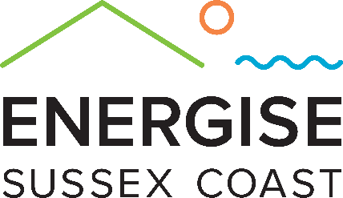  National Lottery TNL fund logo  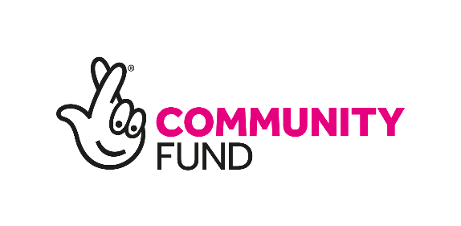
Copy | Please use the information in the links provided. We can also help with the copy if needed
Deadline | The first training event is in now in Eastbourne on 20th May. Ideally we’d like the first suitcase completed by then if that’s in anyway possible!  If not then asap.

