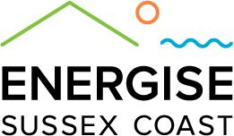
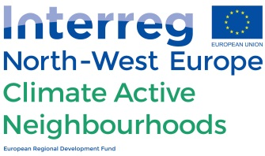

Outreach Coordinator

Application deadline: 14th January

- Varied with a minimum of 10 hours per week
- ASAP - ?
- Salary: £15 ph – contractor hourly rate.

Hours will be agreed each week and will depend on the number of projects and events that are being carried out.

Energise Sussex Coast is looking for a freelance Outreach Coordinator to take forward project work relating to funded projects including the EU Interreg funded Climate Active Neighborhoods programme and to set up the new Energy Caravan Project.

This will be a interesting and varied role suitable for someone with a broad range of experience of community organising, coordination, administration, marketing and fundraising.

The aim is that the role will start at 10 hours a week and as funding is gained for the new projects, the hours and the scope of the role will increase. The first task of the new coordinator will be to fundraise for the Energy Caravan Project.

Project details

Climate Active Neighborhoods
The Outreach Coordinator will lead on the Energy Local Project. This project will recruit 100 homes to take part in a research study to monitor their energy and see if they would benefit from joining a local energy club. The key tasks will be:
- Recruiting 100 homes
- Managing the installation of energy monitors
- Analysing data and preparing a report

Faith and Power
The Bright Ideas funded project is looking to increase the amount of renewable energy generated locally. The outreach coordinator will support this project by gathering data about potential sites and pre-registering them for the Feed In Tariff.

1066 Local Energy Campaign
The Local Energy Campaign aims to increase the amount of renewable energy generated locally. The Outreach Coordinator will lead on the marketing for the campaign.

Energy Caravan
The energy caravan is a mobile energy information and advice service. The Outreach Coordinator will be responsible for:
- Fundraising for the new project
- Developing the idea into a project
- Coordinating the service
- Giving energy advice on the van

Criteria

Essential
- Qualification in Renewable Energies or Environmental Policy, Studies or Science.
- Organised and reliable.
- Experience of community engagement work and door knocking.
- Experience of giving energy advice.
- The ability to work on your own initiative and to work in a team.
- IT and Internet literate with a working knowledge of Wordpress, CMS and Microsoft Office suite software (or equivalent, e.g. OpenOffice.)
- Experience of carrying out a successful online promotion campaign for a community project or organisation.
- Experience of working in the third sector.
- Experience of successfully fundraising for projects.
- Knowledge of new GDPR requirements and a commitment to data protection and confidentiality.
- Knowledge of local organisations and networks beneficial to the aims of ESC.
- Experience of organising and carrying out community outreach events.
- Excellent secretarial/administrative and data input skills.
- Happy to work in a flexible way
- A full clean driving license
- A current DBS certificate.

Desirable
- Experience of working with vulnerable people.
- Experience of mailing lists and database management.

To apply

Please send your CV with a covering letter of no more than 1 page of A4, stating how you meet the criteria to kate@energisesussexcoast.co.uk by 14th January 2018.

